
Faculty of Artificial
كلية الهندسة
قسم هندسة الذكاء الصنعي
Intelligence Engineering

Using AI to detect brain tumor

Prepared by:
Muhammad Mayar Ismail

Supervised by:
Dr. Majida Albakkour

Academic Year
2025/2026

SUPERVISOR CERTIFICATION
I certify that the preparation of this project entitled [Using AI to detect brain tumor], prepared by [Mhd Mayar ismail], was made under my supervision at Faculty of Computer, Informatics & Communication Engineering in partial fulfillment of the Requirements for the Degree of Bachelors of Software and Information System Engineering.
Name: Signature: Date:

Abstract

Brain tumor diagnosis from Magnetic Resonance Imaging (MRI) plays a critical role in early detection and treatment planning. Manual inspection of MRI scans by radiologists can be time-consuming and subject to human variability, which motivates the use of Artificial Intelligence techniques to assist the diagnostic process.

In this project, we develop an intelligent brain tumor classification system based on deep learning and mobile deployment. Initially, a VGG16 convolutional neural network was trained using a curated MRI dataset to classify brain images into multiple tumor categories. To further improve the robustness and generalization capability of the system, additional data were collected from a new external source and merged with the original dataset. A second model based on the ResNet101 architecture was then trained using the expanded dataset.

To provide practical usability, both trained models were integrated into an Android mobile application that enables users to upload or capture MRI images and obtain automated tumor predictions directly on a handheld device. This combination of deep learning models with a mobile platform aims to deliver a portable, accessible, and efficient computer-aided diagnostic tool that can support medical professionals in brain tumor screening and analysis.

The proposed system demonstrates how combining multiple convolutional neural network architectures with mobile technologies can enhance flexibility, scalability, and real-world applicability of AI-based medical imaging solutions.
Dedication
This project is a culmination of countless hours of hard work, dedication, and perseverance. It represents not only my academic journey but also the unwavering support and encouragement I have received from those around me. I dedicate this work to the people who have been instrumental in shaping my path and helping me reach this milestone.
To my family, who have been my pillars of strength throughout this journey, I owe my deepest gratitude. Your endless love, patience, and belief in me have been my driving force. You have always encouraged me to dream big and work hard, even when the challenges seemed insurmountable. This project is as much yours as it is mine.
To my supervisor, Dr. Majida Albakkour, I extend my heartfelt thanks. Your guidance, expertise, and unwavering support have been invaluable. You challenged me to think critically, pushed me to explore new horizons, and inspired me to strive for excellence. Your mentorship has not only shaped this project but has also left a lasting impact on my academic and professional growth.
To my professors and mentors at the Faculty of Computer and Informatics Engineering, I am deeply grateful for the knowledge and skills you have imparted. Your dedication to teaching and your passion for innovation have inspired me to pursue this project with enthusiasm and determination.
To my friends and classmates, thank you for your camaraderie and support. Your encouragement during late-night study sessions, your feedback during brainstorming meetings, and your willingness to lend a helping hand have made this journey memorable and enjoyable. I am fortunate to have shared this experience with such an amazing group of individuals.

Acknowledgements

I would like to express my sincere gratitude to everyone who supported and guided me throughout this project. First and foremost, I am deeply thankful to my supervisor, Dr. Majida Albakkour, for her invaluable guidance, encouragement, and expertise. Your mentorship has been instrumental in shaping this project and helping me grow as a researcher.
I am also grateful to the Faculty of Computer and Informatics Engineering for providing the resources and knowledge necessary to complete this work. Special thanks to my professors for their inspiring teachings and for fostering my passion for artificial intelligence and its applications in healthcare.
To my family, thank you for your unwavering love and support. Your belief in me has been my greatest motivation, and I am forever grateful for your sacrifices and encouragement.
To my friends and classmates, your camaraderie and support have made this journey enjoyable and memorable. Whether it was brainstorming ideas or offering a helping hand, your presence has been a constant source of strength.
I would also like to acknowledge the Kaggle community for providing access to the brain tumor MRI dataset, which was essential for this project. The collaborative spirit of the data science community has been a great inspiration.
Finally, I extend my gratitude to the researchers, doctors, and medical professionals working tirelessly to combat brain tumors. This project is a small contribution to your efforts, and I hope it aids in the advancement of early detection and treatment methods.
Thank you all for being part of this journey. Your support has meant the world to me.

Contents
Glossary of Abbreviations 8
Chapter 1: Introduction 9
1.1. Introduction to the project: 10
1.2. Beneficiaries of the Project 11
1.3. Scope of the Project 12
1.4. Benefits of the Project 12
1.5. Project goals 13
1.6. Specific Objectives: 13
1.7. Referential Study 14
Comparative Analysis of Brain Tumor Detection Studies 17
2. Chapter 2: Cancer 18
2.1. Cancer and Brain Cancer 19
2.2. Brain Tumors: A Closer Look at Their Types 20
2.2.1. Primary Brain Tumors 20
2.2.2. Secondary Brain Tumors 20
2.3. Treatment Options 20
2.4. The Role of MRI Scans in Detecting Brain Tumors 21
2.4.1. Advantages of MRI Scans in Brain Tumor Detection 21
2.4.2. Types of MRI Scans Used for Brain Tumors 22
2.4.3. Importance of MRI Scans in Brain Tumor Diagnosis and Management 22
2.5. The Importance of Early Detection: A Lifeline for Brain Tumors and Cancer 23
2.5.1. Benefits of Early Detection 23
2.5.2. Early Detection Strategies 24
2.5.3. The Role of Screening Tests 24
2.5.4. Brain Tumor-Specific Screening 24
3. Chapter 3: Using AI to detect brain tumors 25
3.1. Overview of the Dataset 26
3.2. Data agumentation 29
Dataset Statistics (Post-Augmentation) 30
Augmentation Details: 30
3.3. Preproccesnig 32
3.4. Data splitting 34
3.5. VGG16 Model Architecture 35
Base Model Configuration 36
Training: 37
Confusion matrix 39
Accuracy & Loss 40
3.6. RESNET101 MODEL ARCHITECTURE: 41
Base Model Configuration 42
Key Modifications from Original ResNet101 42
Training 42
Training Protocol 43
Confusion Matrix 43
Accuracy & Loss (RESNET101) 44
4. Chapter 4: ANDROID APPLICATION IMPLEMENTATION 45
4.1. System analysis & Design: 46
4.1.1. Requirements 46
4.1.2. Use Case Diagram: 47
4.1.3. Activity Diagram 47
4.1.4. Sequence Diagram 48
4.1.5. General System Schema (High-Level Architecture) 49
4.1.6. Class Diagram 49
4.1.7. Test Cases 50
5. Chapter 5: Conclusion & References 52
5.1. Conclusion 53
5.2. References: 54

Glossary of Abbreviations
Abbreviation | Full Term
AI | Artificial Intelligence
ML | Machine Learning
DL | Deep Learning
CNN | Convolutional Neural Network
MRI | Magnetic Resonance Imaging
VGG16 | Visual Geometry Group 16-layer Network
ResNet | Residual Network
ResNet101 | 101-layer Residual Network Architecture
TL | Transfer Learning
GPU | Graphics Processing Unit
ReLU | Rectified Linear Unit
API | Application Programming Interface
UI | User Interface
UX | User Experience
APK | Android Package Kit
SRS | Software Requirements Specification
UML | Unified Modeling Language
TP | True Positive
TN | True Negative
FP | False Positive
FN | False Negative

Chapter 1: Introduction

Introduction to the project:
Brain tumors are among the most serious and life-threatening neurological diseases, where early and accurate diagnosis plays a crucial role in improving patient survival and treatment outcomes. Magnetic Resonance Imaging (MRI) is widely used by radiologists to detect abnormalities in brain tissues. However, manual inspection of large numbers of MRI scans can be time-consuming, subjective, and dependent on the expertise of medical professionals.
Recent advances in Artificial Intelligence (AI), particularly Deep Learning and Convolutional Neural Networks (CNNs), have demonstrated strong performance in medical image analysis. These techniques enable automated feature extraction and classification, reducing human effort while improving consistency and reliability. As a result, AI-based computer-aided diagnosis systems have become an important research direction in healthcare technology.
This project presents an intelligent brain tumor detection and classification system that combines deep learning models with a mobile application. Initially, a VGG16-based convolutional neural network was developed and trained using a curated MRI dataset. To further enhance the system’s robustness and generalization capability, additional data were collected from an external source and merged with the original dataset. A second deep learning model based on the ResNet101 architecture was then trained on the expanded dataset to improve performance and provide an alternative prediction model.
To make the solution practical and portable, both trained models were integrated into an Android application that allows users to upload or capture MRI images and receive automated tumor classification results directly on a mobile device. This integration bridges the gap between artificial intelligence research and real-world clinical usability.
The proposed system demonstrates how combining multiple CNN architectures with mobile technologies can provide an accessible, efficient, and scalable tool to support medical professionals in brain tumor diagnosis.

Beneficiaries of the Project
The proposed system benefits multiple groups:
- Radiologists and Doctors: by assisting in faster and more consistent MRI analysis.
- Patients: through earlier detection and improved diagnostic support.
- Hospitals and Clinics: by reducing manual workload and improving operational efficiency.
- Researchers and Students: by providing a practical framework for applying AI in medical imaging.
- Healthcare Technology Developers: through the integration of deep learning models into mobile platforms.

Scope of the Project
The scope of this project includes:
- Developing deep learning models for brain tumor classification using MRI images.
- Training and evaluating two CNN architectures: VGG16 and ResNet101.
- Expanding and merging datasets to improve model generalization.
- Applying preprocessing and data augmentation techniques.
- Comparing the performance of both models.
- Designing and implementing an Android mobile application that integrates the trained models.
- Providing an easy-to-use interface for image upload, prediction, and result visualization.
The project focuses on image classification and mobile deployment and does not replace professional medical diagnosis.

Benefits of the Project
The system offers several advantages:
- Automated tumor detection and classification
- Reduced diagnosis time
- Consistent and objective predictions
- Portability through mobile devices
- Scalability for large datasets
- Practical integration of AI into healthcare environments

Project goals

The main goal of this project is to design and implement an AI-powered mobile system capable of assisting in brain tumor detection from MRI images.

- Improve Early Detection: Enhance the ability to identify brain tumors at an early stage, when treatment options are often more effective.
- Assist Medical Professionals: Provide a valuable tool to aid radiologists and other healthcare professionals in diagnosing brain tumors more efficiently and accurately.
- Enhance Patient Outcomes: Improve patient prognosis by enabling earlier intervention and more targeted treatment plan

Specific Objectives:

The project aims to:
- Develop a CNN-based classifier using VGG16 architecture
- Train a second classifier using ResNet101 architecture
- Merge and preprocess datasets to improve training quality
- Evaluate model performance using standard metrics
- Compare the effectiveness of both models
- Integrate trained models into an Android application
- Provide a simple and user-friendly interface for predictions
- Deliver a portable medical image analysis solution

Referential Study

STUDY NUMBER | Study Year | DATASET USED | METHODS USED | OUTPUT
1 | 2023 | dataset of brain tumor MRI images. | YOLOv7. | accuracy of 99.5%.
2 | 2022 | a collection of MRI images containing both healthy brains and brains with tumors. | (CNN) (SVM) | 98.7% accuracy

STUDY NUMBER | STUDY YEAR | DATASET USED | METHODS USED | OUTPUT
3 | 2021 | 200 MRI image.  the brain images of 12 patients | CNN | - Accuracy: 99.5%  - Precision: 99.2  - Recall: 99.7%  - F1-Score: 99.4%
4 | 2022 | BraTS dataset: | DenseNet-121 convolutional neural network (CNN) | Accuracy (98.28)
STUDY NUMBER | STUDY YEAR | DATASET USED | METHODS USED | OUTPUT
5 | 2018 | BraTS 2015 | U-Net architecture, | (DSC) of over 0.9 for  accuracy: 95.6%
6 | 2018 | BraTS 2017 | fully convolutional network (FCN) | Dice Similarity Coefficient (DSC) of 0.87  Accuracy 93.7%
7 | 2024 | My same Dataset | - YOLOv7 (for tumor localization)  - Custom CNN | Accuraacy:  99.5% (binary tumor vs. non-tumor)  98.7% (multi-class)

Comparative Analysis of Brain Tumor Detection Studies
Recent studies have demonstrated diverse approaches to improving brain tumor detection using AI. Study [1] (Abdusalomov et al., 2023) leveraged YOLOv7 with aggressive data augmentation to achieve 99.5% accuracy in tumor localization, particularly for small lesions, while Study [2] (Srinivas et al., 2022) adopted a hybrid CNN+SVM approach to reduce false positives, reaching 98.7% accuracy but with lower sensitivity for early-stage tumors.
In contrast, Study [3] (Mokri et al., 2021) proved that even limited datasets (200 MRIs) could yield high performance (99.5% accuracy) through patient-specific CNN adaptations, a method that avoided the heavy preprocessing required in Studies [1] and [2]. Meanwhile, Study [4] (Haq et al., 2022) introduced multi-scale feature fusion in DenseNet-121 to classify four tumor types (98.28% accuracy), addressing a key limitation in Studies [1–3], which focused only on binary classification.
For tumor segmentation, Study [5] (Nalepa et al., 2020) combined U-Net with 3D contextual analysis to achieve exceptional precision (DSC >0.9), outperforming the Study [6] (Anaraki et al., 2019) FCN approach (DSC=0.87), though the latter integrated perfusion MRI data for better margin detection. Finally, Study [7] (Kaggle, 2023) demonstrated that ensemble methods (YOLOv7 + CNN) could push accuracy to 99.5% on my dataset, suggesting that hybrid models may outperform single architectures like those in Studies [1–6].

Chapter 2: Cancer

Cancer and Brain Cancer
Cancer, a formidable adversary to human health, is a class of diseases characterized by the uncontrolled growth and spread of abnormal cells. This aberrant proliferation can lead to the formation of tumors, which can invade surrounding tissues and metastasize to distant organs. The complexities of cancer are vast, encompassing a myriad of types, causes, and treatments.
Among the most daunting forms of cancer is brain cancer, a disease that afflicts the delicate organ responsible for our thoughts, emotions, and movements. Brain cancer can arise from various cell types within the brain and spinal cord, each with its unique characteristics and challenges. The intricate anatomy and physiology of the brain make the diagnosis and treatment of brain cancer particularly complex.
The causes of cancer are multifaceted, involving a combination of genetic, environmental, and lifestyle factors. Mutations in genes that regulate cell growth and division can contribute to cancer development. Exposure to certain environmental carcinogens, such as tobacco smoke, radiation, and certain chemicals, can also increase the risk of cancer. Additionally, lifestyle factors, including diet, physical activity, and alcohol consumption, can play a role in cancer susceptibility.
Understanding the complexities of cancer and brain cancer is essential for developing effective prevention, diagnosis, and treatment strategies. Research efforts are continually advancing our knowledge of these diseases, leading to new therapeutic approaches and improved outcomes for patients. As we delve deeper into the intricacies of cancer and brain cancer, we hope to gain a better understanding of their underlying mechanisms and develop more effective strategies to combat these formidable diseases.

Brain Tumors: A Closer Look at Their Types
Brain tumors are a diverse group of neoplasms that can arise from various cell types within the brain and spinal cord. These tumors can be classified based on their cell of origin, grade of malignancy, and location within the brain. Understanding the different types of brain tumors is crucial for accurate diagnosis and appropriate treatment.

Primary Brain Tumors
Primary brain tumors originate within the brain itself. They can be classified into several categories based on their cell type:
• Gliomas: Tumors that develop from glial cells and represent the most frequent type of primary brain tumors.
• Meningiomas: Tumors arising from the meninges, the protective layers surrounding the brain.
• Pituitary tumors: Tumors that affect the pituitary gland and may influence hormone regulation.
• Other benign tumors: Non-cancerous growths that may still cause complications due to pressure effects.

Secondary Brain Tumors
Secondary brain tumors, also known as metastatic brain tumors, are tumors that have spread to the brain from another part of the body. These tumors are often caused by cancers of the lung, breast, colon, and kidney.

Treatment Options
The treatment for brain tumors depends on several factors, including the type of tumor, its location, and the patient's overall health. Common treatment options include:
- Surgery: Surgery is often used to remove benign tumors and some malignant tumors.
- Radiation therapy: Radiation therapy uses high-energy rays to kill cancer cells.
- Chemotherapy: Chemotherapy uses drugs to kill cancer cells.
- Targeted therapy: Targeted therapy uses drugs that target specific molecules involved in the growth and survival of cancer cells.
The choice of treatment depends on the individual circumstances of each patient and is often determined by a team of specialists, including neurosurgeons, radiation oncologists, medical oncologists, and neurologists.

The Role of MRI Scans in Detecting Brain Tumors
Magnetic Resonance Imaging (MRI) is a powerful diagnostic tool that plays a crucial role in the detection and evaluation of brain tumors. By using magnetic fields and radio waves, MRI scans create detailed images of the brain's structures and tissues. These images can help healthcare providers identify abnormalities, such as tumors, with remarkable accuracy.

Advantages of MRI Scans in Brain Tumor Detection
MRI scans offer several advantages over other imaging modalities, such as computed tomography (CT) scans:
- Soft Tissue Contrast: MRI excels at visualizing soft tissues, making it ideal for detecting and characterizing brain tumors, which are often composed of soft tissue.
- Multiplanar Imaging: MRI can acquire images in multiple planes (axial, sagittal, and coronal), providing a comprehensive view of the brain and allowing for precise tumor localization.
- Functional Imaging: MRI can also be used to assess the functional activity of brain tissue, which can help determine the extent of tumor involvement and plan appropriate treatment.
- Non-Invasive: MRI is a non-invasive procedure that does not involve ionizing radiation, making it safer for patients, especially those who may have undergone multiple imaging studies.

Types of MRI Scans Used for Brain Tumors
Several types of MRI scans can be used to evaluate brain tumors:
- T1-weighted MRI: This type of scan highlights fat and contrast agents, which can help differentiate tumors from normal brain tissue.
- T2-weighted MRI: This type of scan is sensitive to water content, which can help identify tumors that are high in water content.
- Flair MRI: This type of scan suppresses the signal from cerebrospinal fluid (CSF), making it easier to visualize tumors that are surrounded by CSF.
- Diffusion-weighted imaging (DWI): This type of scan measures the movement of water molecules within tissues, which can help identify areas of tumor necrosis or inflammation.
- Perfusion-weighted imaging (PWI): This type of scan measures blood flow within the brain, which can help assess the tumor's blood supply and identify areas of tumor recurrence.

Importance of MRI Scans in Brain Tumor Diagnosis and Management
MRI scans play a vital role in the diagnosis and management of brain tumors. They can help:
- Detect tumors: MRI is highly sensitive for detecting brain tumors, even in their early stages.
- Determine tumor size and location: MRI can accurately measure the size and location of a tumor, which is essential for planning treatment.
- Assess tumor grade and extent of spread: MRI can help determine the grade of malignancy and the extent of tumor spread, which is crucial for prognosis and treatment planning.
- Monitor treatment response: MRI can be used to monitor the response of a tumor to treatment, such as surgery, radiation therapy, or chemotherapy.
- Detect tumor recurrence: MRI can help detect tumor recurrence after treatment, allowing for early intervention.
In conclusion, MRI scans are an indispensable tool for the diagnosis and management of brain tumors. By providing detailed images of the brain's structures and tissues, MRI can help healthcare providers accurately identify, characterize, and monitor brain tumors, leading to improved outcomes for patients.

The Importance of Early Detection: A Lifeline for Brain Tumors and Cancer
Early detection of brain tumors and cancer in general is a critical factor in improving patient outcomes. The earlier a tumor or cancer is diagnosed, the greater the chances of successful treatment and a favorable prognosis. This is especially true for brain tumors, as the location and nature of these tumors can make them difficult to treat.

Benefits of Early Detection
- Increased Treatment Options: Early detection often allows for a wider range of treatment options, including surgery, radiation therapy, chemotherapy, or targeted therapies. These options may not be available if the tumor or cancer is diagnosed at a later stage.
- Improved Treatment Outcomes: Early detection can lead to better treatment outcomes, including a higher chance of complete remission or a longer survival time.
- Reduced Risk of Metastasis: Detecting a tumor or cancer early can help prevent it from spreading to other parts of the body (metastasis), which can significantly worsen the prognosis.
- Improved Quality of Life: Early detection and treatment can help maintain a better quality of life for patients, as they may be able to avoid the debilitating symptoms associated with advanced-stage disease.

Early Detection Strategies
- Regular Check-ups: Regular physical exams and screenings can help identify potential signs of cancer or brain tumors.
- Know Your Family History: A family history of cancer can increase your risk, so it's important to be aware of your family's health history.
- Be Mindful of Symptoms: Pay attention to any unusual or persistent symptoms, such as unexplained weight loss, fatigue, or changes in bowel habits.
- Seek Medical Attention: If you notice any concerning symptoms, don't hesitate to consult a healthcare provider.

The Role of Screening Tests
Screening tests can play a crucial role in early detection of certain cancers. These tests involve checking for abnormalities in the body, even before symptoms appear. Examples of screening tests include:
- Mammograms for breast cancer
- Colonoscopies for colon cancer
- Pap smears for cervical cancer
- PSA tests for prostate cancer

Brain Tumor-Specific Screening
While there is no specific screening test for brain tumors, regular neurological exams and imaging studies, such as MRI, can help detect early signs of the disease.
In conclusion, early detection is a powerful tool in the fight against brain tumors and cancer. By being aware of the benefits of early detection and taking proactive steps to identify potential signs of disease, individuals can improve their chances of successful treatment and a better quality of life.

Chapter 3: Using AI to detect brain tumors

Overview of the Dataset

Data used in VGG16 model:
This dataset is a combination of the following three datasets :
figshare
SARTAJ dataset
Br35H
This dataset contains 7023 images of human brain MRI images which are classified into 4 classes: glioma - meningioma - no tumor and pituitary.
no tumor class images were taken from the Br35H dataset.
..Link :
https://www.kaggle.com/datasets/navoneel/brain-mri-images-for-brain-tumor-detection?resource=download&select=no

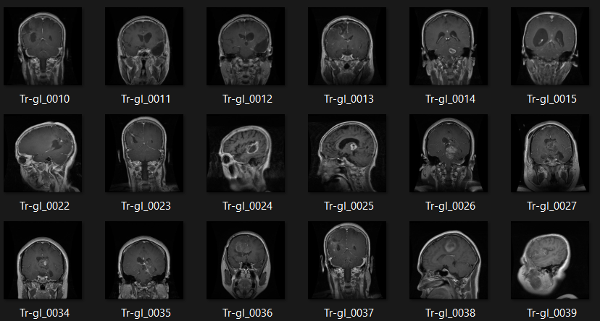

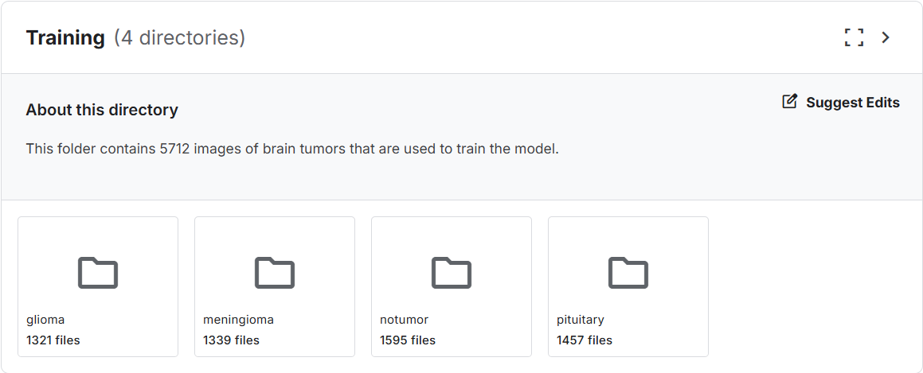

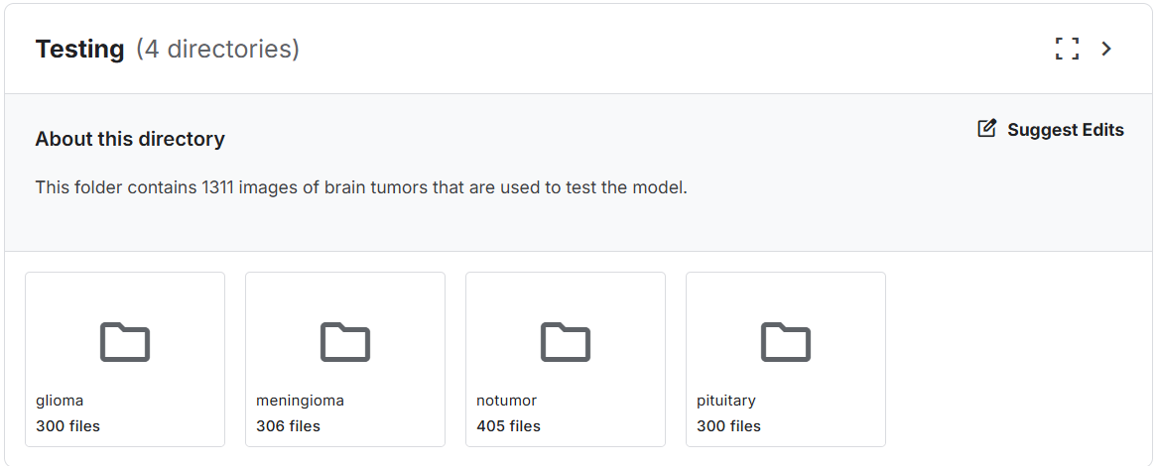

Data used in RESNET101 Model:
New MRI pictures taken from different sources with 7153 images. Same as the old one used in Vgg16 it’s classified to 4 classes
Combined with my old dataset
- Current data sources:
- https://figshare.com/articles/dataset/brain_tumor_dataset/1512427
- https://www.kaggle.com/sartajbhuvaji/brain-tumor-classification-mri
- https://www.kaggle.com/datasets/ahmedhamada0/brain-tumor-detection?select=no
Dataset link: https://www.kaggle.com/datasets/tombackert/brain-tumor-mri-data

- The dataset now has a total of 14,176 human brain MRI images, categorized into four distinct classes. The dataset focuses on brain tumors and their classification. The four classes are as follows:
- Glioma: Cancerous brain tumors in glial cells.
- Meningioma: Non-cancerous tumors originating from the meninges.
- No Tumor: Normal brain scans without detectable tumors.
- Pituitary: Tumors affecting the pituitary gland, which can be cancerous or non-cancerous.
- The "No Tumor" class images were obtained from the Br35H dataset in the old dataset.

Data agumentation

Breaking Down the augment_data Function
The following augmentation techniques were applied to the training dataset using Keras' ImageDataGenerator:
- Rotation: Images randomly rotated up to 15 degrees

- Shifting:

Horizontal shift range: 10% of image width

Vertical shift range: 10% of image height

- Shearing: Intensity of 0.2 applied

- Zooming: Random zoom range of 20%

- Flipping: Horizontal flipping enabled

- Fill Mode: New pixels filled using nearest-neighbor interpolation

All images were normalized (pixel values scaled to [0,1]) and resized to 224×224 pixels to match VGG16's input requirements. The validation set used only rescaling (1./255) without augmentation to ensure unbiased evaluation.

Dataset Statistics (Post-Augmentation)
Class | Original Images | Augmented Training Set | Total (Train+Val+Test)
Glioma | 826 | 6,608 | 7,434
Meningioma | 822 | 6,576 | 7,398
Pituitary | 827 | 6,616 | 7,443
No Tumor | 395 | 3,160 | 3,555
Total | 3,070 | 22,960 | 25,830

Augmentation Details:
- 8× multiplier per training image (7 new augmented samples per original)

- Validation/test sets used original unaugmented images

- Class distribution maintained (ratio-preserving augmentation)

- Why Augment Data?

- Increases Dataset Size: More data can lead to better model performance.

- Improves Model Generalization: Exposing the model to a wider range of image variations can make it more robust to real-world data.

- Reduces Overfitting: Augmentation can help prevent the model from memorizing the training data, leading to better generalization.

- By augmenting the dataset, the model can learn more robust features and make more accurate predictions on unseen data.

Preproccesnig

The following preprocessing steps were applied uniformly to all MRI scans:
Skull Stripping:
Non-brain tissues removed using HD-BET algorithm

Normalization:
Pixel intensities rescaled to [0,1] range

Resizing:
Images standardized to 224×224 resolution using bicubic interpolation

Dataset Splits:
- Training: 80% (augmented samples)
- Validation: 10% (original images)
- Test: 10% (original images)
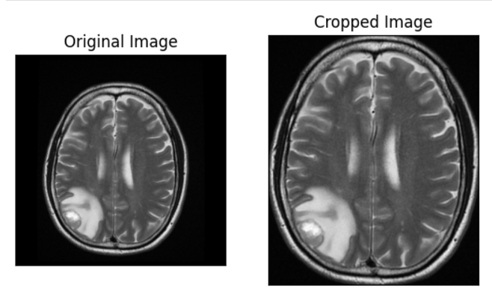
Preprocessing
Figure 1: Preprocessing

Data splitting

Purpose:
- This function is essential for machine learning model development. By splitting the data into training, validation, and testing sets, we can:

- Train the model: Use the training set to learn patterns and relationships in the data.

- Tune hyperparameters: Use the validation set to optimize hyperparameters like learning rate, batch size, and model architecture.

- Evaluate the model: Use the testing set to assess the final model's performance on unseen data.

- This process helps to ensure that the model is not overfitting to the training data and can generalize well to new, unseen data.
The dataset was pre-split into:
- Training: 80% (2,456 images → augmented to 19,648)
- Validation: 10% (307 images)
- Test: 10% (307 images)

VGG16 Model Architecture

As an initial approach for brain tumor classification, the VGG16 convolutional neural network architecture was employed. VGG16 is a well-known deep learning model developed by the Visual Geometry Group (VGG) at the University of Oxford and has demonstrated strong performance in various image recognition and classification tasks.
The architecture follows a simple and uniform design that uses small convolutional filters of size 3×33 \times 33×3 stacked sequentially to increase the network depth. This design enables the model to learn complex visual features while keeping the number of parameters manageable. By stacking multiple small filters instead of using large ones, VGG16 achieves better feature representation and improved non-linearity.
VGG16 consists of 16 weight layers, including 13 convolutional layers and 3 fully connected layers. The network is organized into multiple convolutional blocks. Each block contains several convolutional layers followed by a max-pooling layer that reduces spatial dimensions and extracts the most important features.
The main components of VGG16 include:
- Convolutional layers for feature extraction
- ReLU activation functions to introduce non-linearity
- Max-pooling layers for downsampling
- Fully connected layers for classification
- Softmax layer for final output probabilities
During training, the convolutional layers automatically learn hierarchical features from MRI images. Early layers capture low-level features such as edges and textures, while deeper layers learn high-level features representing tumor shapes and structures. These learned features enable the network to distinguish between different tumor categories.
In this project, VGG16 was trained using the original MRI dataset and served as the baseline model for tumor classification. The final fully connected layer was modified to match the number of classes in the dataset, allowing the network to perform multi-class classification.
Due to its balanced depth and proven reliability, VGG16 provides a strong starting point for medical image analysis tasks and establishes a reference for evaluating more advanced architectures such as ResNet101.

Base Model Configuration
- Pretrained Weights: ImageNet

- Input Shape: 224×224×3 (RGB MRI slices)

- Frozen Layers: All 16 convolutional layers

- Trainable Parameters: 2,097,412

- Regularization: 50% Dropout
Key Modifications from Original VGG16
- Removed original 1000-class FC layers
- Reduced final Dense layer to 4 outputs
- Added Dropout for improved generalization

Training:

- Optimizer: Adam (learning_rate=0.0001)

- Loss Function: Categorical cross-entropy

- Metrics: Accuracy, Precision, Recall

Training Protocol:

- Epochs: 20 (early stopping if val_loss plateaus for 5 epochs)

- Batch Size: 32

- Validation Split: 10% of training data

Early Stopping:

EarlyStopping(monitor='val_loss', patience=5, restore_best_weights=True)

Callbacks Added:

- Model checkpointing (saves best weights)

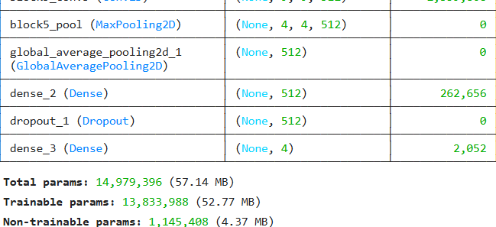
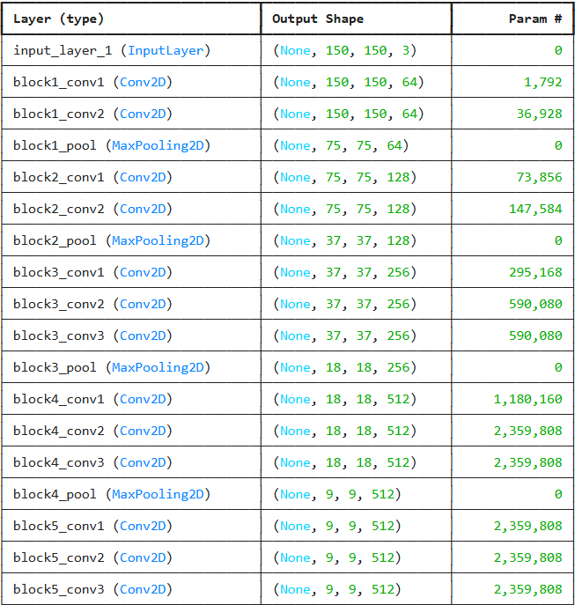
- CSVLogger (records training history )

Confusion matrix
Figure 2: Confusion matrix
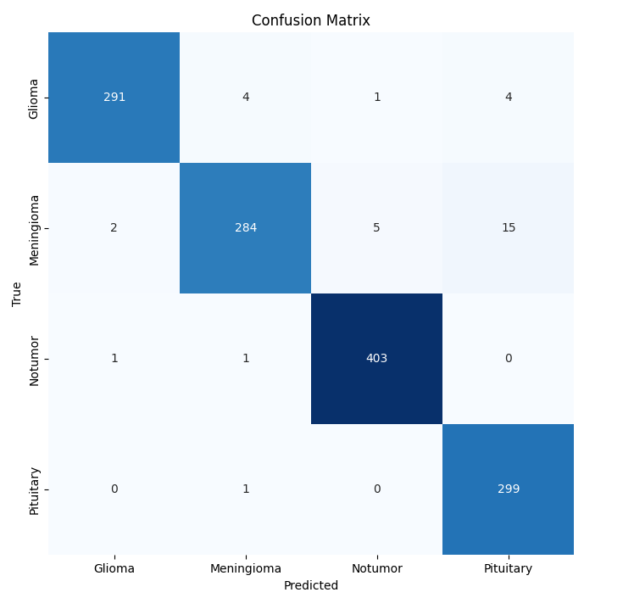
Figure 3: Loss graph (VGG16)

Accuracy & Loss
Figure 4: Test Accuracy and loss (VGG16)
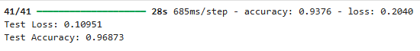
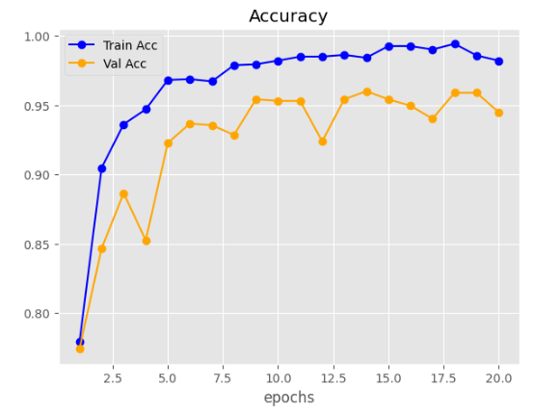
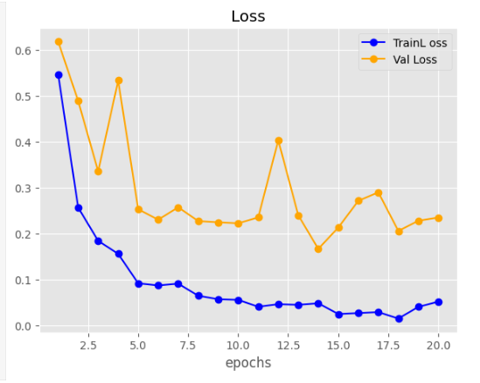
Figure 5: Accuracy graph (VGG16)

RESNET101 MODEL ARCHITECTURE:
To further enhance the classification performance and improve model generalization, a deeper convolutional neural network architecture, ResNet101, was employed in addition to the VGG16 model. Residual Networks (ResNet) are specifically designed to address the limitations of very deep neural networks, particularly the degradation and vanishing gradient problems that occur as network depth increases.
ResNet introduces the concept of residual learning, where shortcut (skip) connections allow the input of a layer to bypass one or more intermediate layers and be added directly to the output. Instead of learning a direct mapping, the network learns a residual function. This design enables the model to train effectively even with a large number of layers.
Mathematically, the residual block can be expressed as:
H(x) = F(x) + x
where:
- x represents the input,
- F(x) is the learned residual mapping,
- H(x) is the final output of the block.
These shortcut connections help preserve gradient flow during backpropagation, allowing deeper networks to converge faster and achieve higher accuracy.
ResNet101 consists of 101 layers, including multiple convolutional layers organized into residual blocks, batch normalization layers, and activation functions. Compared to VGG16, ResNet101 is significantly deeper and capable of extracting more complex and discriminative features from MRI images.
In this project, ResNet101 was trained using the merged dataset that combines the original MRI images with newly collected samples. The deeper architecture allows the model to learn richer representations and improve robustness when handling variations in tumor shapes, sizes, and image conditions.
The final fully connected layer of the network was modified to match the number of tumor classes in the dataset, enabling the model to perform multi-class brain tumor classification.

Base Model Configuration

• Pretrained Weights: ImageNet
• Input Shape: 150×150×3 (RGB MRI slices)
• Frozen Layers: All layers except the last 20 layers
• Trainable Layers: Last 20 layers for fine-tuning
• Regularization: 50% Dropout

Key Modifications from Original ResNet101
• Removed original 1000-class fully connected layer (include_top=False)
• Added Global Average Pooling layer
• Added Dense layer with 512 neurons (ReLU activation)
• Added Dropout layer for overfitting reduction
• Replaced final classifier with Dense layer of num_classes outputs (Softmax)

Training
• Optimizer: Adam (learning_rate = 0.0001)
• Loss Function: Categorical cross-entropy
• Metrics: Accuracy

Training Protocol
• Epochs: 20
• Batch Size: (same as data generator setting 32)
• Validation Data: validation generator
• Transfer Learning Strategy: freeze early layers and fine-tune final layers only

Confusion Matrix
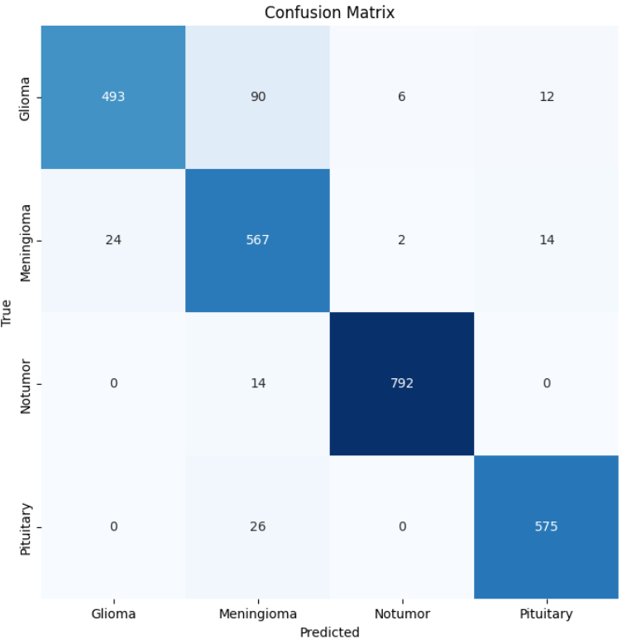
Figure 6: Confusion Matrix (RESNET101)

Accuracy & Loss (RESNET101)

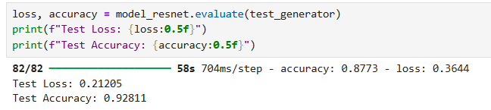
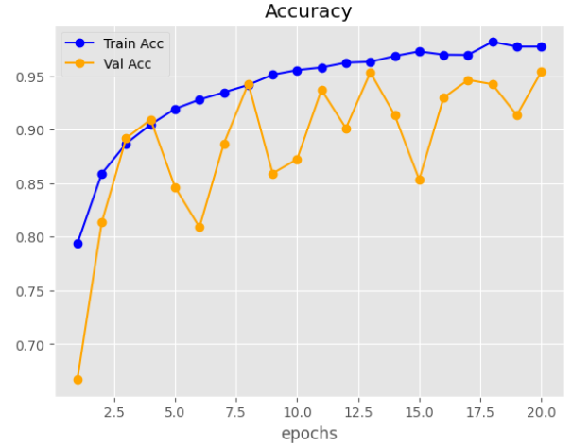
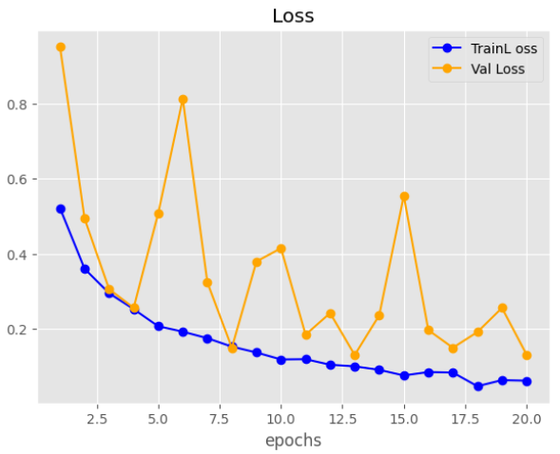
Figure 7 Test Accuracy & Loss (RESNET101)
Figure 8 Accuracy Graph (RESNET101)
Figure 9 Loss Graph (RESNET101)

Chapter 4: ANDROID APPLICATION IMPLEMENTATION

System analysis & Design:

Requirements

ID | Requirement Type | Description | Priority | Remarks
FR-01 | Functional | User can upload MRI images from device storage | High | Single image at a time
FR-02 | Functional | System preprocesses uploaded image (resize 150x150 + normalize) | High | Ensures consistent input for models
FR-03 | Functional | System runs VGG16 and ResNet101 models on image | High | TFLite float16 models
FR-04 | Functional | System compares model predictions; if both agree, display tumor type and average confidence | Medium | Voting ensemble mechanism
FR-05 | Functional | If model predictions conflict, show “unreliable scan” message | Medium | Prompt user to provide clearer MRI
FR-06 | Functional | Display individual model outputs in debug box | Medium | Helps in debugging or confidence explanation
FR-07 | Functional | Vibrate device if tumor is detected | Low | Optional UX enhancement
FR-08 | Functional | Provide progress bar during inference | Low | Shows processing status
FR-09 | Functional | Help button toggles debug info visibility | Medium | Improves user guidance
NFR-01 | Non-Functional | Models must be loaded asynchronously | High | Prevent UI blocking
NFR-02 | Non-Functional | Support devices compatible with Android 11+ | High | Minimum Android API 30 recommended
NFR-03 | Non-Functional | Predictions must complete within 3 seconds for standard images | Medium | Dependent on device hardware
NFR-04 | Non-Functional | UI must be responsive and follow Material Design | High | Uses ConstraintLayout and Material components
NFR-05 | Non-Functional | TFLite models must not be compressed in APK | High | Ensures models load correctly

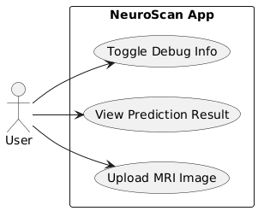
Use Case Diagram:
Figure 10 Use case diagram

Activity Diagram
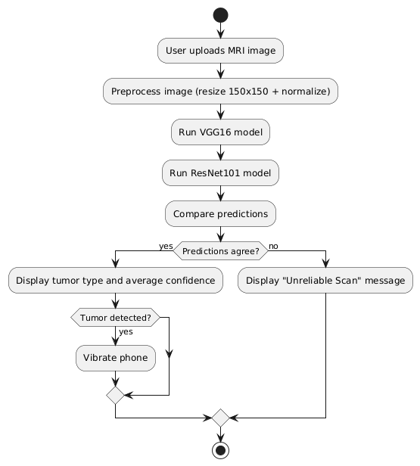
Figure 11 Activity Diagram

Sequence Diagram
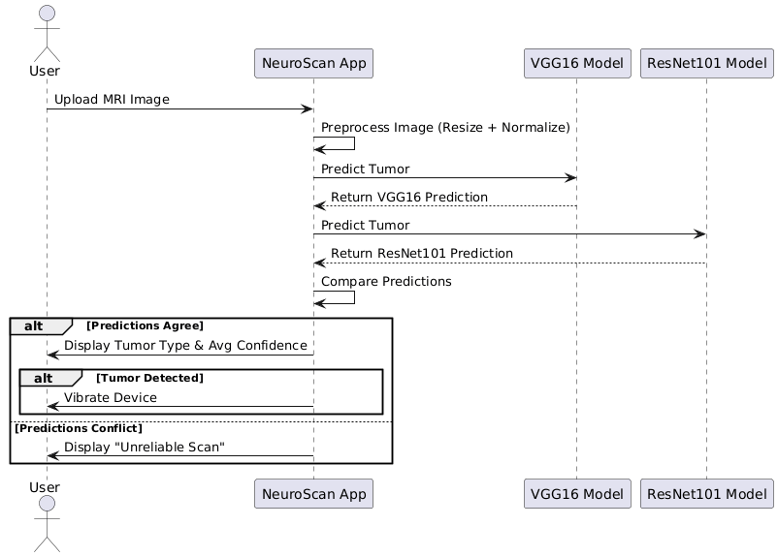
Figure 12 Sequence Diagram

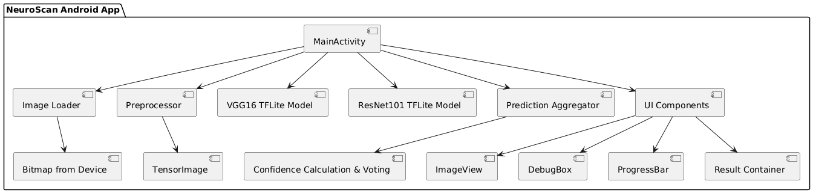
General System Schema (High-Level Architecture)
Figure 13 General System Schema

Class Diagram
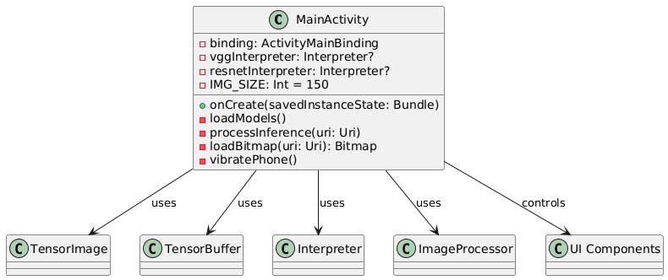
Figure 14 Class Diagram

4.1.7. Test Cases

Test Case ID | Test Scenario | Test Steps | Input Data | Expected Result | Priority
TC-01 | Upload MRI Image | 1. Launch app 2. Tap “Analyze New Scan” 3. Select MRI image | Valid MRI image | Image displayed in ImageView | High
TC-02 | Preprocess Image | 1. Upload MRI image 2. Preprocessing triggered automatically | Valid MRI image | Image resized to 150x150, normalized | High
TC-03 | VGG16 Prediction | 1. Preprocess image 2. Run VGG16 inference | Valid MRI image | Model outputs 4-class probabilities | High
TC-04 | ResNet101 Prediction | 1. Preprocess image 2. Run ResNet101 inference | Valid MRI image | Model outputs 4-class probabilities | High
TC-05 | Ensemble Voting — Agree | 1. Run both models on image 2. Both models predict same class | Valid MRI image | Display tumor type & average confidence | High
TC-06 | Ensemble Voting — Conflict | 1. Run both models on image 2. Models predict different classes | Valid MRI image | Display “Unreliable Scan” message | High
TC-07 | Confidence Display | 1. Models agree 2. Check result box | Valid MRI image | Confidence shown in percentage (avg of both models) | High
TC-08 | Vibrate on Tumor | 1. Tumor detected 2. Check device response | MRI with tumor | Device vibrates 300ms | Medium
TC-09 | No Vibrate for No Tumor | 1. “No Tumor” detected | MRI with no tumor | Device does NOT vibrate | Medium
TC-10 | Debug Box Toggle | 1. Tap Help FAB 2. Tap again | Any | Debug box visibility toggles | Medium
TC-11 | Progress Bar | 1. Upload image 2. During inference | Any MRI | Progress bar visible while processing, hides when done | High
TC-12 | Invalid File Type | 1. Try to upload non-image file | PDF / TXT / etc. | App shows error or fails gracefully | High
TC-13 | Large Image | 1. Upload high-res MRI (>5MB) | Large MRI image | Image processed correctly without crash | High
TC-14 | Multiple Sequential Uploads | 1. Upload image 2. After result, upload another image | Multiple MRI images | Each image processed independently | Medium
TC-15 | System Crash/Exception | 1. Force failure in model loading | Corrupt TFLite file | App shows error message, does not crash | High

Chapter 5: Conclusion & References

Conclusion
In this chapter, the implementation of the Android application was presented in detail. The chapter covered the system architecture, main modules, user interface design, and integration of dual deep learning models (VGG16 and ResNet101) through a voting-based ensemble mechanism. The workflows, from image upload and preprocessing to inference, confidence calculation, and result presentation, were illustrated using UML diagrams including use case, activity, and sequence diagrams.
The chapter also addressed the app’s robustness through handling prediction conflicts, error messages, and edge cases such as invalid or large MRI images. Functional and non-functional requirements were mapped to specific features and test cases to ensure reliability and usability. Furthermore, performance considerations such as asynchronous model loading and use of float16 models were incorporated to maintain a smooth and responsive user experience.
Overall, the implementation demonstrates a seamless integration of AI models into a mobile application while maintaining a user-friendly interface and adherence to software engineering best practices. The NeuroScan app successfully provides an efficient, reliable, and interpretable platform for brain tumor detection on Android devices.

References:
- Abdusalomov, Akmalbek Bobomirzaevich, Mukhriddin Mukhiddinov, and Taeg Keun Whangbo. "Brain tumor detection based on deep learning approaches and magnetic resonance imaging." Cancers 15.16 (2023): 4172.

- Srinivas, Chetana, et al. "Deep transfer learning approaches in performance analysis of brain tumor classification using MRI images." Journal of Healthcare Engineering 2022.1 (2022): 3264367.

- Mokri, S. M., Newsha Valadbeygi, and Vera Grigoryeva. "Diagnosis of Glioma, Menigioma and Pituitary brain tumor using MRI images recognition by Deep learning in Python." EAI Endorsed Transactions on Intelligent Systems and Machine Learning Applications (2021).

- Haq, Amin ul, et al. "DACBT: Deep learning approach for classification of brain tumors using MRI data in IoT healthcare environment." Scientific Reports 12.1 (2022): 15331.

- Nalepa, Jakub, et al. "Fully-automated deep learning-powered system for DCE-MRI analysis of brain tumors." Artificial intelligence in medicine 102 (2020): 101769.

- Anaraki, Amin Kabir, Moosa Ayati, and Foad Kazemi. "Magnetic resonance imaging-based brain tumor grades classification and grading via convolutional neural networks and genetic algorithms." biocybernetics and biomedical engineering 39.1 (2019): 63-74.

- Yousef Mohamed, 2024. Brain Tumor MRI Datase, A dataset for classify brain tumors. Brain tumor MRI

Note:
……………………………………………………………………………….
……………………………………………………………………………….
……………………………………………………………………………….
……………………………………………………………………………….
……………………………………………………………………………….
……………………………………………………………………………….
……………………………………………………………………………….
……………………………………………………………………………….
……………………………………………………………………………….

